bonus part :-
- find the IPv4 address of the laptop by running "ipconfig" in cmd
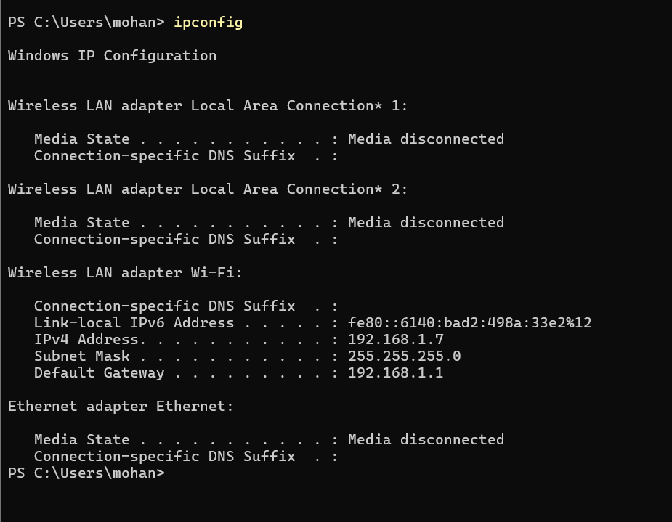

2) the IP address is -> 192.168.1.7
3) On the mobile device, open the following link in a web browser -> http://192.168.1.7:3000
